Sequence Diagram: Home Page
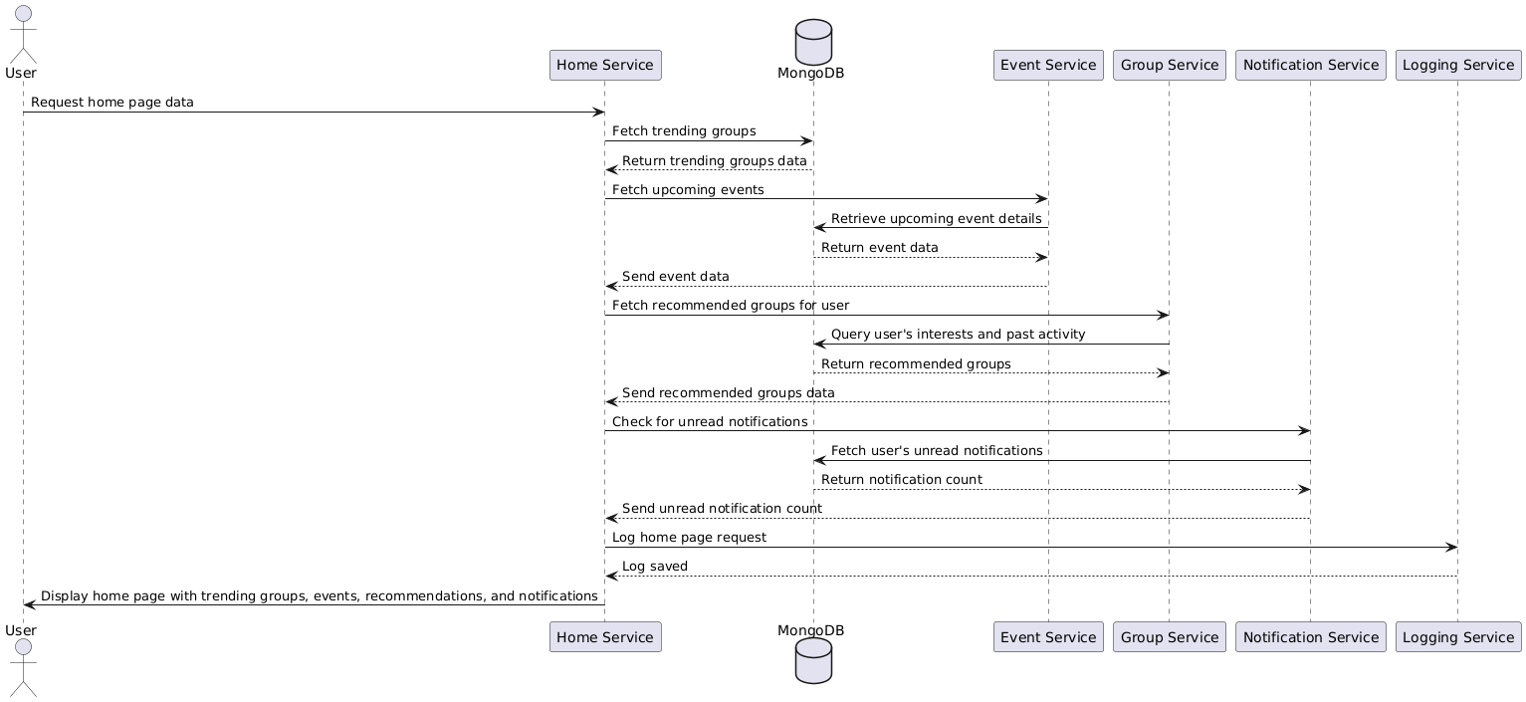

Database
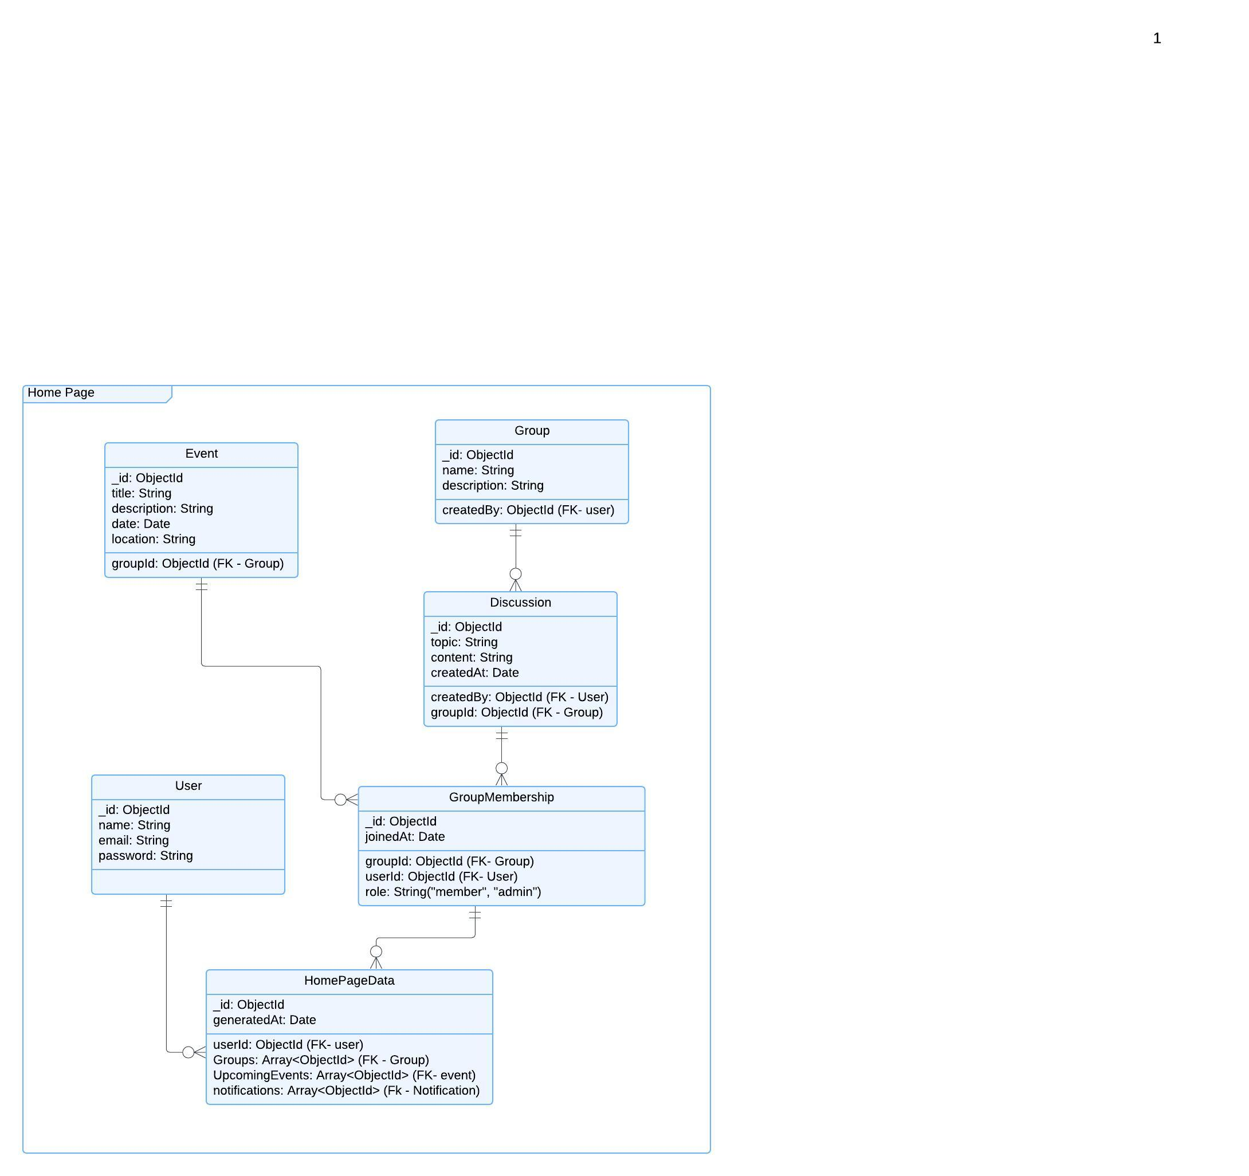

Functional Requirements (FRs)
- FR1: The system shall display trending groups, recommended groups, and upcoming events on the homepage.
- FR2: The system shall fetch and display unread notifications for the user.
- FR3: The system shall provide a search bar for users to search for specific groups, events, or discussions.
- FR4: The system shall provide quick links to recently accessed groups and events on the homepage.
Non-Functional Requirements (NFRs)
- NFR1: The homepage should load in under 2 seconds.
- NFR2: The system should implement caching to reduce database load.
- NFR3: The homepage should support real-time updates for notifications.
- NFR4: The system shall support responsive design, so the homepage is optimized for various devices (desktop, tablet, mobile).

